Create a resource group by using name , location and tags through PowerShell or azure portal

**PowerShell commands:**

**Account-connect:**

Connect-AzAccount

**Resource group creation:**

New-AzResourceGroup -ResourceGroupName "sampletraffic" -Location "east us" -tag @{'resources'='traffic manager'}

Get-AzResourceGroup -ResourceGroupName sampletraffic

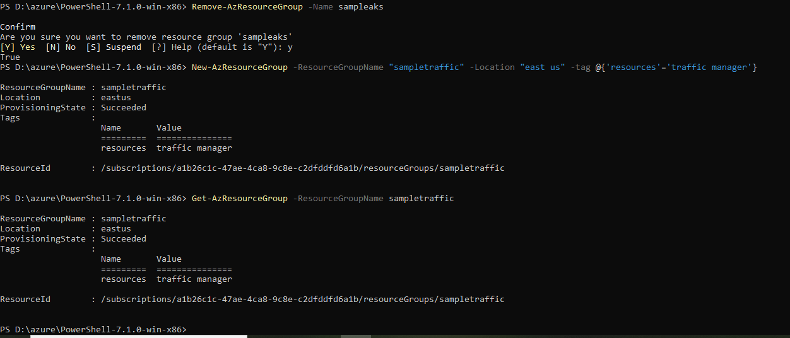

**Deploy arm template with locally stored json files:**

**New-AzResourceGroupDeployment -Name test -ResourceGroupName sampletraffic -TemplateParameterFile "D:\azchlg\traffic manager\azuredeploy.parameters.json" -TemplateFile "D:\azchlg\traffic manager\azuredeploy.json"**

**Deploy arm template using uri:**

New-AzResourceGroupDeployment -Name test -ResourceGroupName **sampletraffic** -TemplateUri ‘<https://raw.githubusercontent.com/kamalanathan1995/azchlg/master/traffic%20manager/azuredeploy.json>’ -TemplateParameterUri ‘https://raw.githubusercontent.com/kamalanathan1995/azchlg/master/traffic%20manager/ /azuredeploy.parameters.json’

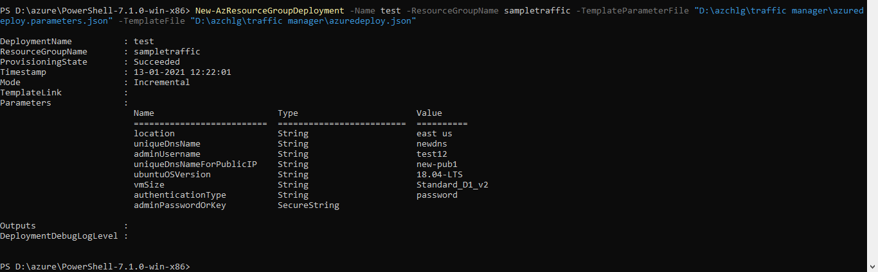

We had added Http port 80 to allow traffic coming from http only.other port traffics will get rejected automatically.

properties": {

"securityRules": [

{

"name": "Port_80",

"properties": {

"protocol": "*",

"sourcePortRange": "*",

"destinationPortRange": "*",

"sourceAddressPrefix": "*",

"destinationAddressPrefix": "*",

"access": "Allow",

"priority": 100,

"direction": "Inbound"

}

}